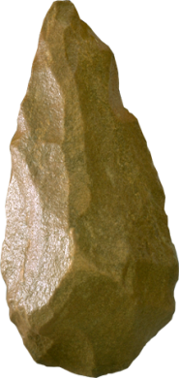 | 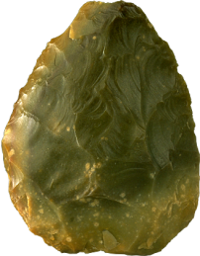 | 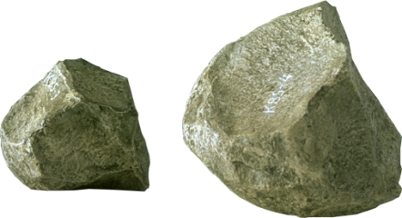 | 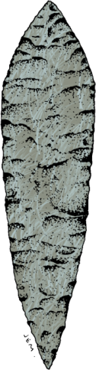
Oldowan | Mousterian | Acheulian | Upper Paleolithic
From 1.5million ya | From 2.5million ya | From 40,000 ya | From 150,000 ya
Homo Neanderthals | Homo Sapiens | Homo Habilis | Homo Erectus
E.g. Hand axe | E.g. Burin | E.g. Levallois point | E.g. Chopper
Simple and crude with only a few flakes removed | Long, thin flakes produced by punch blade method then retouched to produce many tool types | Levallois tool making method uses a prepared core and striking off a large oval flake which is retouched on one side | Typically tear drop shaped with many flakes removed and slight bulge on each broad surface

 |  |  | 
Oldowan | Mousterian | Acheulian | Upper Paleolithic
From 1.5million ya | From 2.5million ya | From 40,000 ya | From 150,000 ya
Homo Neanderthals | Homo Sapiens | Homo Habilis | Homo Erectus
E.g. Hand axe | E.g. Burin | E.g. Levallois point | E.g. Chopper
Simple and crude with only a few flakes removed | Long, thin flakes produced by punch blade method then retouched to produce many tool types | Levallois tool making method uses a prepared core and striking off a large oval flake which is retouched on one side | Typically tear drop shaped with many flakes removed and slight bulge on each broad surface

ANSWERS

 |  |  | 
Oldowan | Acheulian | Mousterian | Upper Paleolithic
From 2.5million ya | From 1.5million ya | From 150,000 ya | From 40,000 ya
Homo Habilis | Homo Erectus | Homo Neanderthals | Homo Sapiens
E.g. Chopper | E.g. Hand axe | E.g. Levallois point | E.g. Burin
Simple and crude with only a few flakes removed | Typically tear drop shaped with many flakes removed and slight bulge on each broad surface | Levallois tool making method uses a prepared core and striking off a large oval flake which is retouched on one side | Long, thin flakes produced by punch blade method then retouched to produce many tool types

